paper01.doc, last uploaded to plan-s.org: 24 May 08

Plan S, Launch Document #1

Prepared by : Henry Fiddler

Original Creation Date: Sunday, March 25, 2007, 6:30 AM

Table of Contents (TOC)

If you read this document sequentially, you will find some extras sandwiched in between these items. The reason is because I have only included the most important items here in the TOC.

There are hyperlinks throughout. Sometimes if you click on a hyperlink, the document will close strangely. This is a bug. If it happens, the workaround is simple. Just reopen it, and insert a single space anywhere in the document without saving. Then you can click the hyperlinks and the document will not close on you!

Part 1

Overview & Summary of Plan S, Launch Document #1

Part 2

Outline.

I. Definitions

II. Problem Statement

III. Immediate Goals

IV. Ultimate Goals

V. RFP, Request for Proposals

VI. Tasks List

VII. Plan S, General Description & Primary Components

VIII. Specialist <> Generalist View < Extensive list of over 100 specialized areas of knowledge that contribute to the generalist view, that forms the basis of Plan S.

Part 3

Outline.

III. Major Needs

IV. My Position

V. Resource List, Overview/Description < formerly the "stuff list"

VI. Resource List (notes, locations, for archiving) ...

A. important web resources ...

B. my past writings ...

- 1979, HSIP, Human Survival Insurance Policy, about 13,000 words:

- 1996, CSEN, Common Sense 1996, 152 page book draft

C. paper notes I have written over the years ...

- 3x5, in office box

3) Pn's (spiral notebooks), office, van, etc.

4) folders, manila, tan vat, S-DAY, CSEN, book notes

graphics that need professional attention

D. commercially produced materials, misc (my possession) ...

F. computer files ...

- \r\or\san.pco < funding sources

- \r\cp\csen\* < Common Sense 1996 & Plan S files

3) \r\or\lib* < books, audio books, videos, movies

4) \r\or\bm* < Internet/web bookmarks

5) \r\cp\quotes.pco < Quotations

6) \mnby: Miller1 & 2, Petrocollapse, SDay*, Strangest_Secret, TAGR
^ mp3 recordings re Plan S, Peak Oil and Personal Development

7) emails to/fr William Kotke of 12/09-25/2006 \\kottke

8/9) emails to John Randall

G. computer files, Plan S, indexed here ...

Part 4

ps_kotke.doc, 12/25/06, E-mail trail with William Kotke, 12/09-25/06

Subject: Need Help, Are You Available?

Subject: Response From Henry Fiddler #1

Subject: Response From Henry Fiddler #2

5 point recap

Plan S, Single Paragraph Description

Basis for 10 million year species span

5 paradigm shifts to the "gene centric" view

6 point conclusion

Subject: Response From Henry Fiddler #5

Further insights into Plan S, 13 points

Part 5

03/20-22/07, emails to John Randall

Subject: Reflections on Meeting

Ken Wilber on Evolutionary Psychology

Reflections on "renewable energy"

Subject: Re: Peak oil

My primary focus is not on peak oil

Renewables

Sources of mobility

Peak oil fear mongers

Science versus religion

Resource Based Economy

Subject: Re: Peak oil, Afterthoughts

Misc reflections on previous email

Part 1

Overview & Summary of Plan S, Launch Document #1

Hi guys!

Plan S is about redesigning civilization to a sustainable model (for the 10 million year long term), and then transitioning to it. Accordingly, it is a huge undertaking, and it continually challenges me, which is why I am now forced to ask for outside help and support. I am also mindful of my own mortality and realize that this body of work needs to be shared and passed on. It is 40 years in the making.

What you will find below is a patchwork quilt of various writings. If you are patient and use the hyperlinks, I think most of it will be clear. When there are questions, just call or email, or we can talk when I see you shortly.

Most of the main points of Plan S and this launch project are covered below in one place or another, however I will summarize here:

- 10 million years is my estimate of a likely species-span for humanity. Thus, Plan S is about living sustainably for 10 million years.
- Re. “doom and gloom” and negative thinking, Plan S provides a breath of fresh air. This is due to the long term time frame, and the infusion of new knowledge over the past two centuries. By moving away from the immediate planetary crisis to the long term, we are able to see that humanity now stands on the brink of an unprecedented breakthrough to sustainable ways of living.
- We also defeat short term negative thinking by moving away from seeing ourselves as individuals struggling to survive in the short term. Instead, we move towards seeing ourselves as members of homo sapiens, a species which now seeks to learn to live sustainably over the long term, in the vast ecosystem of life.
- Plan S sets a date in the future called S-Day on which a worldwide paradigm shift occurs. While the infrastructure looks the same, after S-Day the attitude and direction of society shifts from unsustainable/waste to sustainable/conservation.
- The concept for S-Day is inspired by Dr Jack Lessinger’s research into socioeconomic waves which he calls Lessinger Waves. Dr Lessinger describes overlapping waves which create a phenomenon called an “age of depression”. S-Day is designed to defeat this phenomenon.
- The conservation and efficiency movements are apparently unaware of Jevons Paradox (see Wikipedia). While conservation often benefits the individuals practicing it, it ironically harms our planetary ecosystem. This is because resources conserved by a minority, are then wasted by the majority. Plan S is “Jevons Paradox aware” and designed to defeat it with S-Day, when a planet wide paradigm shift happens in a single day.
- Plan S will in most ways be the opposite of our wasteful and unsustainable prevailing western civilization culture. There will need to be a special transition period between the two. Planning for an orderly transition is also part of Plan S.
- Plan S relies heavily on the Personal Development Industry’s understanding of the power of the human mind to set and achieve goals and to strive for success. Plan S believes that the human mind is at the root of all of our problems, and also relies on two other recent mind disciplines: Evolutionary Psychology and Neuroscience.
- A key component of Plan S is a new worldwide economic and currency model, called the “resource based economy”. It is in part inspired by the writings of the late Ludwig Von Mises, father of the Austrian School of Economics, and a key proponent of laissez faire free market capitalism.
- There will likely be many objections to the details of Plan S, and other competing plans are welcome. Plan S therefore lays out (in the Specialist <> Generalist View below), all of the issues that any competing general plan should take into account and/or address.
- With this document, I am launching a worldwide virtual organization to move Plan S forward. My desire is to see that virtual organization become a full fledged policy institute (ie. think tank) ASAP. The mission is to present Plan S to planetary management for eventual implementation at a critical moment in the future.
- Planetary management is presently provided by “the world order”, often the target of conspiracy theorists. Plan S doesn’t agree with this mode of thought. Instead, these powerful people are seen as no different than the rank and file of humanity. We are all members of the same species, intelligently responding to our inherited genetic programming. By taking this view, we move beyond the crippling “us-them” thinking of the activist community and build powerful alliances instead.
- This organization needs executive management and a host of other services that I am not qualified to provide. My talent is as a researcher, planner, and problem solver. I need to confine my efforts to that which I do best, and get help for all the rest.
- Regarding financing I know very little, other than the fact that there is a ton of capital out there, looking for projects that correct the dismal state of affairs facing humanity. I have not presented a budget, since I don’t know how. What I do know is that I will need standard compensation, as will most others who come on board full time. I can no longer continue to work as an entertainer, and pursue Plan S as a hobby on the side.
- A budget needs to be drawn up for a pilot project lasting 6 to 12 months, and employing 2 to 6 individuals, during the initial phases of RFP, archiving and interpreting existing resources.

Part 2

This outline is based on a page of handwritten notes made in February, 2007.

I. Definitions
A. Plan S, S-Day
1) A plan for a sustainable complex civilization for the next 10
million years, where "S" could mean any of:
2) sustainable, sustainability
3) survival
4) species
5) save the world
6) solar
7) solution box
B. WC1: Western Civilization 1
1) Agriculture, Ancient Greece to Newton, ~500 BC to 1687 AD
C. WC2: Western Civilization 2
1) Early Industry, The Coal Age, 1687 to 1900
D. WC3: Western Civilization 3
1) Latter Industry, The Petroleum Age, 1900 to present
E. CFR: Council on Foreign Relations
F. TLC: Trilateral Commission
G. TWO: The World Order, meaning: CFR + TLC + Bilderberg
II. Problem Statement
A. Time is short for WC3. Humanity needs a new plan ASAP.
B. Time is short for me personally. I am aging and have already had
some medical challenges.
C. Life is short. A long time is needed to assemble enough
information to develop a general plan. This is therefore a
multi-generational project.
D. I developed Plan S over the last four decades. It has been my
hobby, while I earned my living in the computer and entertainment
industries. Due to lack of funding, no assitance, and working in
my spare time, Plan S is not well documented. If I become
incapacitated, it may possibly be lost forever. Since Plan S is
very unique, I am now making it my vocation. I want it to become
well documented, and knowledge of it spread to persons of power
and influence worldwide.
E. References for "the big picture"
1) See the Specialist <> Generalist View below.
2) Out of these hundreds of disciplines, the two most basic, root
causes of humanity's problems are Evolutionary Psychology and Peak
Oil. For a detailed understanding of these two root causes:
3) How to Want What You Have, Chapter 3, Human Nature, by Dr Timothy
Miller. This book is readily available from the library or
Amazon.com. The Chap. 3 audio book excerpt is currently on my
server, 48 minute mp3:
http://www.htfiddler.net/tsb/Ch3_Human_Nature.mp3
4) Jay Hanson's dieoff.org, his Maximum Power page:
http://www.dieoff.org/page193.htm
5) Matt Savinar's Peak Oil site:
http://www.lifeaftertheoilcrash.net
III. Immediate Goals
A. To get Plan S out of my mind, and into the minds of other humans.
B. To build a core virtual organization to document and spread
awareness of Plan S.
C. Needed are a CEO, project manager, researchers, co-authors, ghost
writers, web designers, graphic artists, fundraisers, marketers,
etc.
D. The core organization is to be assembled from the RFP process below.
This file needs to be rewritten and posted on the web, for
worldwide response.
IV. Ultimate Goals
A. To develop and bring Plan S to the worldwide attention of our
current planetary management. This would include presentations to
individual members of TWO, at TWO meetings, at policy institutes
(think tanks), and to any other individuals with the power to
influence world policies.
B. At a time in the future, as a consensus develops among these
groups and individuals that a new direction is necessary for
humanity, there will already be general awareness of Plan S.
Then, it may be considered for implementation, along with other
worthy plans.
V. RFP, Request for Proposals
A. Cutoff date to submit: x (actually, we may leave it open ended)
B. Email submissions to: x (fill in later)
C. We are looking for initial core members of the "Virtual Plan S
Incubator".
D. Since each situation will be unique, interested parties are
requested to submit a proposal, as explained below.
E. Who may submit: individuals, couples, groups, organizations.
F. Submit proposals in any combination of formats such as: .txt,
.doc, .htm, .mp3, .wma, .wmv, .mov. These should be easily
readable on Windows, Mac or Linux.
G. Submit any length from a page to a book. If lengthy, please
include an executive summary.
H. Submit all that may apply, or be relevant for consideration:
I. resume(s)
J. background, skills, qualifications, why interested, past and
current related work and projects
K. any major agreements and/or concerns with Plan S
L. State willingness to travel and/or relocate, should the need
arise.
M. If willing to travel, how much and how often?
N. financial exchange: need for financial compensation, ability to
contribute financially and/or volunteer
O. Availability: full time or part time? If part time, what is your
availability?
P. If you are currently employed, and will need to terminate or take
leave from that employment, what length commitment will you need,
in order to do so? Or, could you work on a part time basis, while
we get acquainted?
Q. any other relevant information you would like to submit
VI. Tasks List
C. archive existing materials from the "resource list"
D. interpret "
E. curriculum development, based on above
F. media development: web, books, DVD's
G. web based learning program, Powerpoint slideshow, etc.
H. video conferencing
I. phone bridges
J. travelling, conducting 3 to 7 day seminars, worldwide
K. fundraising, grant writing
L. marketing
VII. Plan S, General Description & Primary Components
A. Humanity has a long history of building complex civilizations that
end in collapse (ref Toynbee, Tainter, Diamond). We are now
witnessing the collapse of WC3. Plan S is a plan for a new
complex civilization, that can sustain for the long term,
~10 million years.
B. I didn’t list anymore here, since the main points are listed in
other places in this document.
VIII. Specialist <> Generalist View
A. Below is an ongoing and growing list of all the specialized areas
of knowledge that contribute to an understanding of our problems,
solutions, or both. Due to our extreme specialization in the 21st
century, getting a generalist's view is difficult and extremely
time consuming. I have spent 40 years!
B. The list below is copied from another file, is in rough form,
unsorted, and needs work. I just don't have time right now to
deal with it, but better than nothing!

[Note: The Specialist <> Generalist View has been deleted from this document since a more recent version is available here at: notes.htm.]

Part 3

Outline:

I. TOC (moved to top of entire document)
II. Executive Summary (Didn’t have time. See Overview at top.)
III. Major Needs
A. Plan S Policy Institute (Think Tank)
B. Executive and Project Management
C. Director of Research
D. Strategic Planning
E. Fundraising & Grant Writing
F. Operating Capital
IV. My Position
A. Lead Researcher & Plan S Architect
V. Resource List, Overview/Description
A. The resource list (formerly called the “stuff list”), is a list of most of the resources in my physical domain, that have built up over the years. It is provided here to give an idea of the extent of material to be archived, interpreted and organized, to bring Plan S into a form that can be presented to humanity. It is also provided so that in case I become incapacitated, these resources can be located and interpreted, to the best extent possible.
VI. Resource List (notes, locations, for archiving) ...
A. important web resources ...
1) How to Want What You Have, Chapter 3, Human Nature, by Dr Timothy
Miller. This book is readily available from the library or
Amazon.com. The Chap. 3 audio book excerpt is currently on my
server, 48 minute mp3:
http://www.htfiddler.net/tsb/Ch3_Human_Nature.mp3
2) Jay Hanson's dieoff.org, his Maximum Power page:
http://www.dieoff.org/page193.htm
3) Matt Savinar's Peak Oil site:
http://www.lifeaftertheoilcrash.net
4) Dr Jack Lessinger, Lessinger Waves & Penturbia:
http://www.predicting2020.com
5) My July, 2003 Solution Box page:
http://www.htfiddler.net/tsb/tsb.htm
6) Von Mises' Human Action, online:
http://www.mises.org/humanaction.asp
B. my past writings ...

- 1979, HSIP, Human Survival Insurance Policy, about 13,000 words:

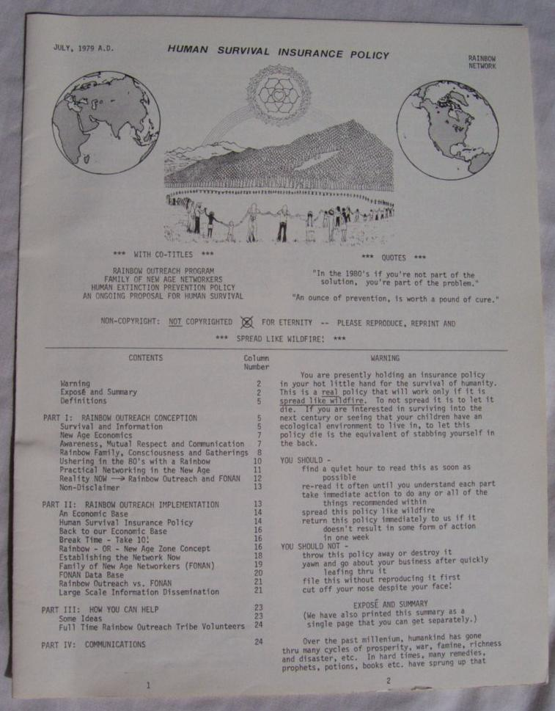

2) 1982, REN, Resource Exchange Network

3) 1996, CSEN, Common Sense 1996, 152 page book draft

This one was done in an old version of Word and I printed about 35 copies at Kinko’s. Unfortunately, it was already out of date before the ink was dry!

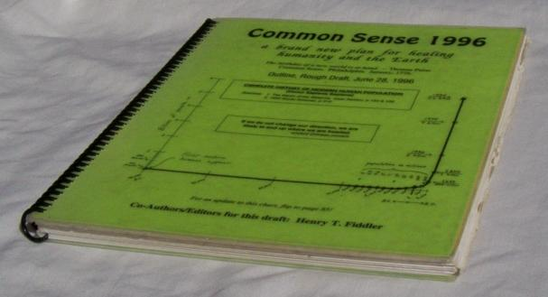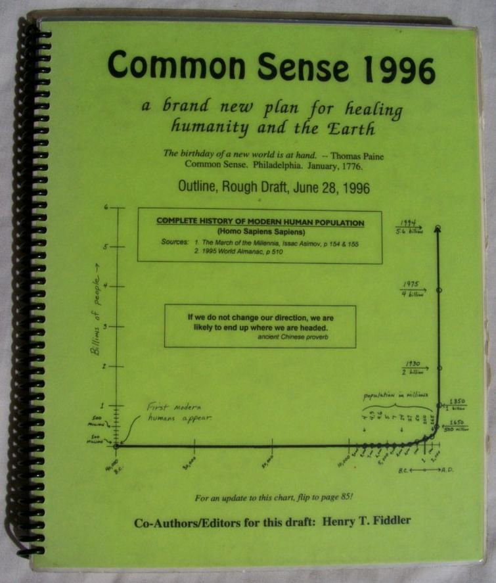

C. paper notes I have written over the years ...
1) 3x5, in office box
2) 3x5, in van

These are the 3x5 pad notes I jot when I’m driving or the computer isn’t on, or my spiral 3x5 notebook isn’t handy. I make note of all ideas, regardless of how worthless they might seem! There are hundreds of these notes, and most will require some interpretation:

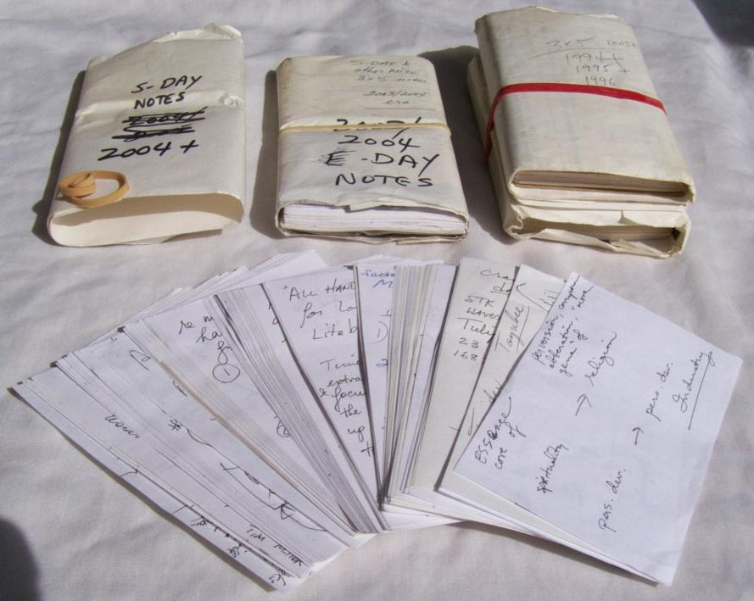

3) Pn's (spiral notebooks), office, van, etc.

These date back to 1982. I’m on #46 right now. Many of these notes have been transcribed to computer or a file folder, however many have not due to lack of time. Most notes will require interpretation:

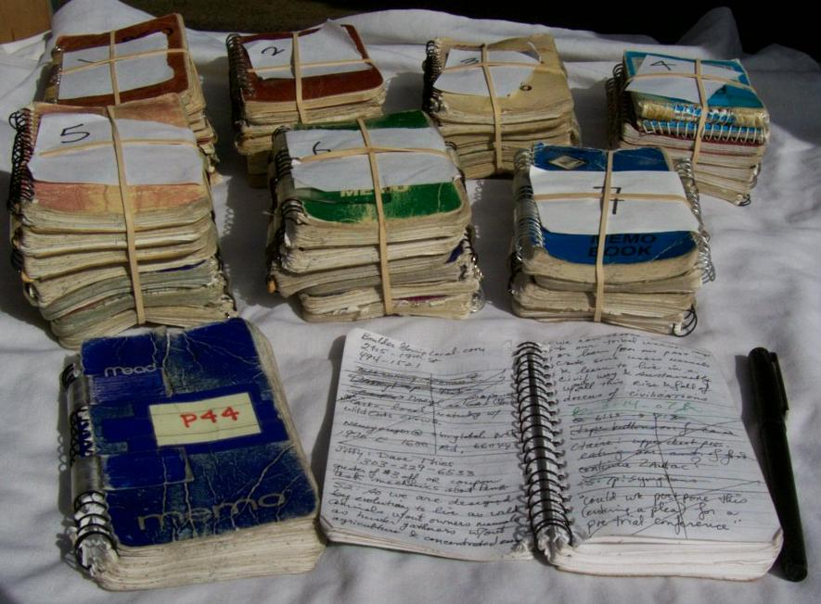

4) folders, manila, tan vat, S-DAY, CSEN, book notes

Here are some of the folders that have a heavy concentration of Plan S resources in them.

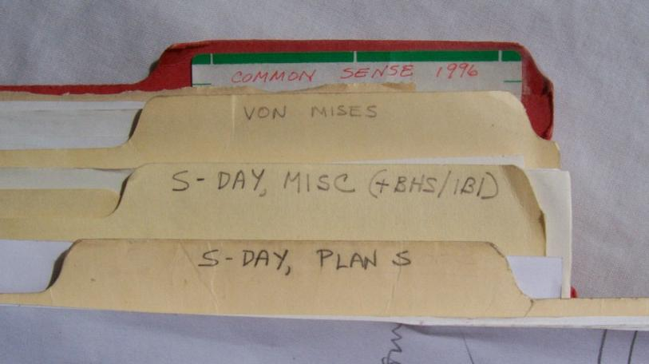

The following images show some of the many graphics that beg for professional attention:

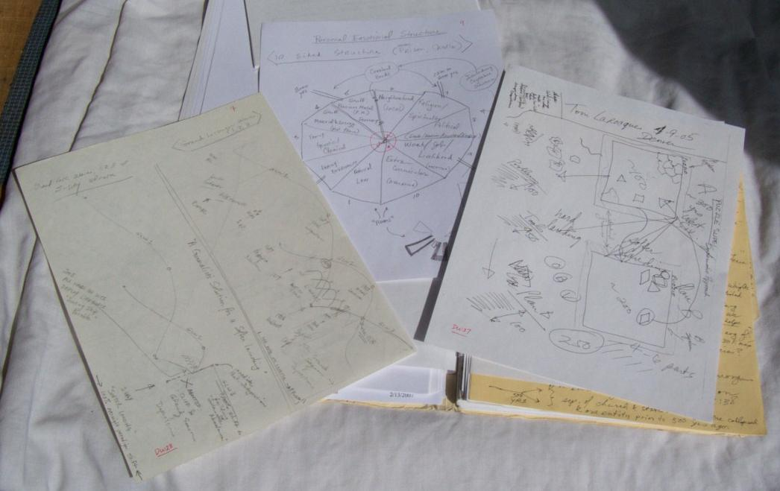

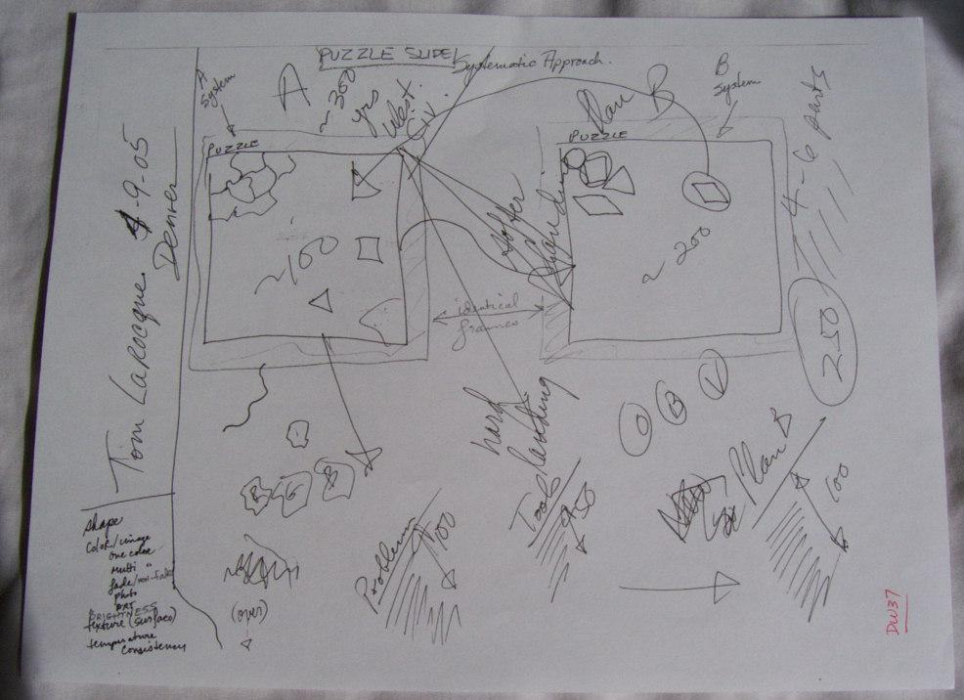

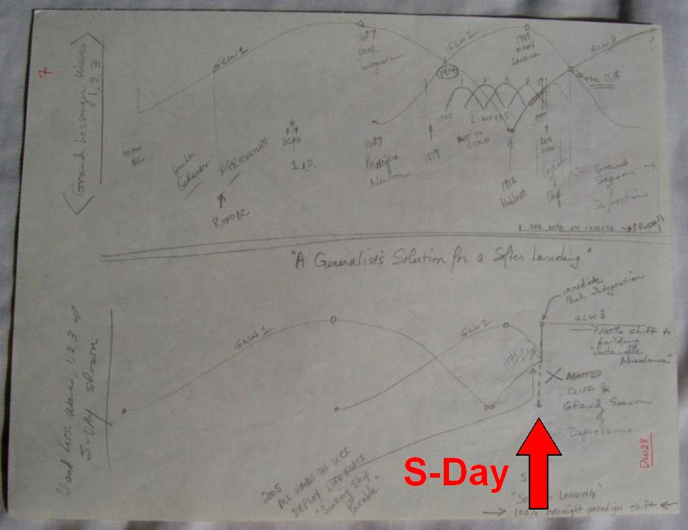

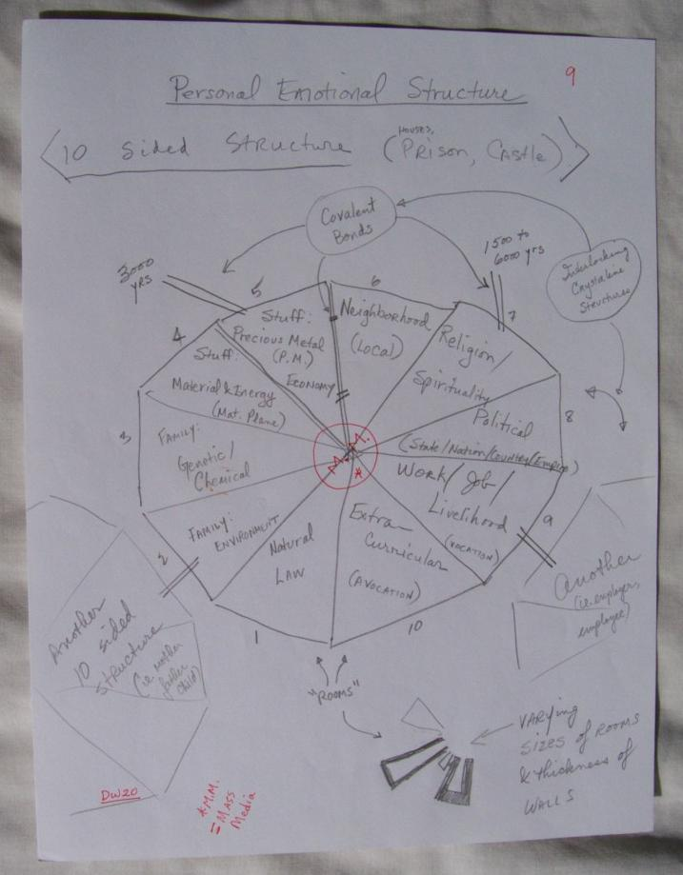

5) paper piles, office, CB, storage
D. commercially produced materials, misc (my possession) ...
1) books, shelves, boxes, van
2) peak oil poster, in tube
3) National Geographic
4) Time Magazine, shelves, van
5) cassette programs, some already to mp3 (see below) ...
a) Earl Nightingale, several
b) Zig Ziglar
c) TAGR
E. video ...
1) DVD's, End of Suburbia, etc.
2) VHS, in CB, van ??? (Ancient Prophesies, etc)
F. computer files ...
1) \r\or\san.pco

In this file I maintain a list of potential funding sources. I have identified about 200 so far.

2) \r\cp\csen\*

This is where my research notes exist from my 1996 Common Sense project. I also keep Plan S files here. The file csencur.doc 538k, contains the text of my book Common Sense 1996, shown above.

Directory of C:\R\CP\CSEN

03/23/2007 05:23 PM <DIR> .
03/23/2007 05:23 PM <DIR> ..
10/20/1996 03:15 PM 3,203 BILLTODD.PCO
10/20/1996 02:46 PM 2,720 BILLTODD.WK1
07/03/1996 02:20 PM 2,295 BOOKCHG.WK1
05/15/2006 05:42 PM 3,261 BVR.PCO
12/08/2006 10:51 PM 58,776 CSENAA.PCO
04/24/2003 11:57 AM 57,772 CSENAB.PCO
12/14/2006 08:11 PM 58,812 CSENAC.PCO
08/22/2005 03:38 AM 52,598 CSENAD.PCO
08/22/2005 03:41 AM 55,224 CSENAE.PCO
12/21/1998 10:22 AM 50,189 CSENAF.PCO
08/15/2003 01:25 AM 14,169 CSENAG.PCO
12/21/2003 12:34 PM 48,616 CSENAH.PCO
09/29/1996 06:02 AM 59,493 CSENAI.PCO
11/21/2003 04:42 AM 26,985 CSENAJ.PCO
07/25/1996 11:01 PM 37,184 CSENAK.PCO
07/25/1996 11:03 PM 39,864 CSENAL.PCO
08/03/1996 03:05 AM 51,513 CSENAM.PCO
07/27/1996 07:11 PM 45,803 CSENAN.PCO
07/28/1996 04:37 PM 55,377 CSENAO.PCO
08/03/1996 01:21 PM 57,962 CSENAP.PCO
08/03/1996 03:56 PM 32,340 CSENAQ.PCO
11/20/2006 02:52 AM 54,415 CSENAR.PCO
02/07/2007 12:27 AM <DIR> CSENARC
03/21/2007 11:06 AM 51,681 CSENAS.PCO
02/12/1997 03:27 AM 45,359 CSENAT.PCO
02/12/2003 04:25 AM 60,672 CSENAU.PCO
09/22/1996 06:40 PM 32,418 CSENAV.PCO
09/22/1996 07:49 PM 12,087 CSENAW.PCO
01/21/1997 12:39 PM 19,192 CSENAX.PCO
09/15/1997 04:03 PM 32,718 CSENAY.PCO
12/17/1997 11:51 AM 8,260 CSENAZ.PCO
09/20/2000 09:07 PM 538,112 csencur.doc
08/02/1996 07:11 PM 40,184 CSENKEY.PCO
09/23/2006 10:25 PM 53,655 CSENOTE.PCO
07/27/1996 07:04 PM 51,066 CSENOTEG.PCO
08/22/2005 04:10 AM 32,676 CSENTBF1.PCO
12/27/2006 06:47 PM 60,875 CSENTBF2.PCO
05/02/1996 06:12 PM 1,069 CSENTPL.PCO
09/24/1996 02:20 PM 2,106 DSKFAX.WK1
08/18/2005 08:32 PM 4,463 IBI.PCO
04/11/1996 04:30 AM 24,866 KEYALPHA.PCO
06/13/2005 03:46 PM 17,920 Population Doubling.xls
03/22/2007 09:31 PM 76,288 ps_kotke.doc
03/23/2007 04:34 PM 8,548 PS_L01.BAK
03/23/2007 04:44 PM 8,548 PS_L01.PCO
03/23/2007 04:49 PM 4,778 PS_L02.BAK
03/23/2007 05:23 PM 4,778 PS_L02.PCO
03/22/2007 09:37 PM 19,456 ps_launch01.doc
03/23/2007 05:23 PM 2,562,048 ps_launch02.doc
03/23/2007 04:12 PM <DIR> PS_LIMG1
02/15/2007 03:13 PM 11,678 ROBBINS.PCO
12/28/2006 09:40 PM 2,448 SONG.PCO
12/30/2006 12:18 AM 29,696 stats.xls
09/17/2005 04:08 AM 7,489 WANN1.PCO
09/17/2005 04:07 AM 1,152 wann2.rtf
10/16/1996 04:07 PM 12,151 ZBIKE1.PCO
08/08/1996 12:16 PM 223,232 ZCOACH1.DOC
08/22/1996 04:21 PM 110,208 ZCOACH2.DOC
09/20/1996 01:05 AM 24,412 ZNET1.PCO
10/24/1996 12:40 AM 24,422 ZNET2.PCO
10/31/1996 08:53 AM 19,537 ZNET3.PCO
10/01/1996 11:33 PM 22,601 ZNET4.PCO
10/31/1996 12:50 PM 41,071 ZNET5.PCO
10/24/1996 01:44 AM 19,427 ZNET6.PCO
10/17/1996 08:59 PM 39,273 ZNET7.PCO
10/19/1996 12:23 PM 35,200 ZNET8.PCO
10/19/1996 12:38 PM 11,886 ZNET9.PCO
10/19/1996 03:28 PM 27,632 ZNETA.PCO
10/20/1996 12:09 AM 23,569 ZNETB.PCO
02/12/2003 01:37 PM 26,433 ZNETC.PCO
10/22/1996 04:38 PM 10,642 ZNETD.PCO
11/05/1996 09:22 PM 20,188 ZNETE.PCO
11/05/1996 09:38 PM 27,765 ZNETF.PCO
10/05/1996 01:16 AM 115,584 ZNETG.DOC
10/26/1996 10:36 PM 29,219 ZNETH.PCO
10/27/1996 12:08 AM 40,792 ZNETI.PCO
11/05/1996 10:24 PM 36,283 ZNETJ.PCO
11/09/1996 09:51 PM 17,643 ZNETK.PCO
06/09/1997 03:06 PM 4,602 ZNETL.PCO
06/15/1997 06:21 PM 13,668 ZNETM.PCO
07/26/1997 12:18 PM 35,707 ZNETN.PCO
07/08/1997 09:48 PM 56,038 ZNETO.PCO
80 File(s) 5,764,042 bytes

3) \r\or\lib*

Here I keep lists of all books, audio books, videos and movies that I have read or viewed, or that I would like to read or view in the future. These lists cover materials back to 1964.

Directory of C:\R\OR\lib*

11/22/2006 12:51 PM 19,527 LIB.PCO
11/16/2005 05:30 PM 54,253 LIBLIST1.PCO
03/12/2007 12:55 PM 59,868 LIBLIST2.PCO
03/21/2007 03:59 PM 11,374 LIBLIST3.PCO
03/21/2007 10:32 PM 50,972 LIBVID.PCO
02/21/2007 06:15 PM 59,324 LIBYEAR1.PCO
12/27/2006 04:57 AM 14,415 LIBYEAR2.PCO
7 File(s) 269,733 bytes

4) \r\or\bm* (pull personal stuff)

In these .htm and .xls files I keep all of my Internet/web bookmarks. There are thousands of bookmarks from the past decade of surfing, many relating to Plan S.

Directory of C:\R\OR\bm*

03/23/2007 03:12 PM 636,928 bm.xls
08/30/2006 08:21 PM 24,828 bm01.htm
08/30/2006 08:22 PM 21,095 bm02.htm
06/06/2001 11:40 AM 22,809 bm03.htm
12/21/2003 12:29 PM 28,693 bm04.htm
12/21/2003 12:41 PM 23,694 bm05.htm
08/14/2000 09:24 PM 14,343 bm06.htm
02/06/2000 11:01 PM 7,096 bm07.htm
07/02/2005 06:22 AM 38,777 bm09.htm
10/24/2006 05:06 PM 16,957 bm10.htm
05/21/2005 11:27 PM 11,285 bm11.htm
06/07/2002 09:20 AM 2,458 bmbob1.htm
04/07/2000 09:32 AM 8,325 bmnam.htm
01/06/2001 04:03 AM 2,558 bmnam2.htm
10/18/2006 12:39 PM 67,053 bmnew.htm
12/03/1999 08:04 PM 2,573 bmstd.htm
03/02/2007 01:30 AM 251,802 bmva.htm
08/06/2005 11:47 PM 55,356 bmvb.htm
02/27/2005 08:03 PM 57,261 bmvc.htm
05/03/2005 01:20 PM 73,572 bmvd.htm
11/07/2003 03:51 AM 22,725 bmxes.htm
21 File(s) 1,390,188 bytes

5) \r\cp\quotes.pco

This file contains all quotes I have collected over the years.

6) \mnby: Miller1 & 2, Petrocollapse, SDay*, Strangest_Secret, TAGR

These folders contain dozens (perhaps hundreds) of hours of mp3 recordings relating to Plan S, Peak Oil and Personal Development as follows:

Miller1, full audio book, How to Want What You Have, Dr Timothy Miller

Miller2, Chapter 3 of above, “Human Nature”. This is also currently on my server, 48 minute mp3:
http://www.htfiddler.net/tsb/Ch3_Human_Nature.mp3

Petrocollapse, all audio from www.petrocollapse.org held in New York City, May 6, 2006. I downloaded these before they pulled them from their site.

Sday*, These folders contain mp3 recordings made during meetings with several individuals that I have explained Plan S to in detail over the past couple years. There are dozens of hours of extended recordings here.

Strangest_Secret, 1956 spoken word record by Earl Nightingale, widely considered the first spoken word personal development recording in history. The strangest secret is: “We become what we think about.”

TAGR, 1960 audio book Think and Grow Rich, Napoleon Hill. Widely considered the all time bible of personal development. The original 1937 edition is in the public domain and available online at:
http://www.free-ebook-editions.info/think-and-grow-rich.shtml

7) emails to/fr William Kotke of 12/09-25/2006 \\kottke
a) originals are @ \pmail\mail in folders z 2006 Copies & Received
b) These are copied and consolidated into a single Word97
document: \r\cp\csen\ps_kotke.doc.

William Kotke is an author who has published 2 books: Final Empire and Garden Planet. He is online at: http://www.rainbowbody.net/Finalempire/AboutKoetke.htm. I was communicating with him by email during December, 2006 about helping with Plan S, however so far nothing has come of these emails, other than some useful written documentation. I have inserted this consolidated document in full, below.

8) email to John Randall of 20 March 2007, Reflections on Meeting
9) " 22 March 2007, Re: Peak oil (+Afterthoughts)

John Randall is a friend in Colorado interested in sustainable development. I met him a few years ago when he was working for the late Dennis Weaver, helping Dennis with his promotion of the hydrogen economy. We had a recent meeting in Boulder and these 3 emails followed. They contain several key Plan S insights. I inserted these emails in full, below.

G. computer files, Plan S, indexed here ...
1) unless otherwise indicated, these are all in folder:
\r\cp\csen
2) \r\or\s?.pco

These are my two most active Plan S files. S1.PCO serves as my main indexing file and the file where I keep many of my special lists. S2.PCO is my active journaling file, where I type in new ideas and concepts as they come to me (if my computer happens to be on and nearby, that is).

Directory of C:\R\OR

03/23/2007 05:23 PM 45,909 S1.PCO
03/21/2007 07:59 PM 54,882 S2.PCO
2 File(s) 100,791 bytes

3) ps_kotke.doc, William Kotke emails consolidated

(explained above at F.7.b., included here below)

Part 4

ps_kotke.doc, 12/25/06, E-mail trail with William Kotke, 12/09-25/06

From: Henry T Fiddler <>
To: Wmkotke@earthlink.net
Subject: Need Help, Are You Available?
Date sent: Sat, 09 Dec 2006 23:26:32 -0700
Send reply to:

Dear William,

Just discovered you and your work via Steven Lagavulin at his
deconsumption.typepad.com blog. I have been into this "save the
world" stuff for 4 decades and can't believe I've missed you so far.
Maybe since you aren't with a major publisher? Anyway, better late
than never.

I am in need of help with a number of projects for which I am not
well qualified and do not have time. I would like to learn of your
availability and possible interest. I will be on the West coast this
winter, and might even be able to meet with you. Or we can
communicate by email and phone.

Check out my solution box page at:

http://www.htfiddler.net/tsb/tsb.htm

It is from 2003, way out of date, and never finished, but it is the
tip of the iceberg that I'm working on. It will give you some hints
of the direction I'm moving.

RSVP
Thanks,
<<Henry>>
303-910-0194 << 24/7

From: "William Kotke" <wmkotke@earthlink.net>
To: <>
Subject: Re: Need Help, Are You Available?
Date sent: Mon, 11 Dec 2006 08:36:42 -0800

Dear Henry, thanks for the message. You need help for projects for which you
do not have time or skill? Am I available? For what?
Wm.

From: "William Kotke" <wmkotke@earthlink.net>
To: <>
Subject: Re: Need Help, Are You Available?
Date sent: Fri, 22 Dec 2006 09:13:57 -0800

Henry, where are those solutions you mentioned?
Wm.

From: Henry T Fiddler <>
To: "William Kotke" <wmkotke@earthlink.net>
Subject: Response From Henry Fiddler #1
Date sent: Sat, 23 Dec 2006 20:27:07 -0700
Send reply to:

> Henry, where are those solutions you mentioned?

Hi William ... got your prev. email and have been very busy, and
unable to send a proper reply. Right now, I am once again having
troubles with a chronic physical problem that greatly diminishes my
ability to use the computer. This is one of the main reasons I need
help. The brain is still working great. The body is not!

You should get 2 emails from me, #1 and #2. This is #1. I am also
forwarding a previous email to a good friend of mine in Oregon who is
a young biologist. It will also help you to understand better what
I'm up to. That forward is #2.

The unfinished 2003 page that I referred to previously gives some
hints:

http://www.htfiddler.net/tsb/tsb.htm

however at that time, I had not yet gotten into:

* Plan S & S-Day
* evolutionary psychology
* neuroscience (limbic system, amygdala, etc.)
* the "dark side" of personal development
* resource based economics
* Austrian Economics (ie. Von Mises)
* L-Waves, as described by Dr Jack Lessinger
* Grand Lessinger Waves
* Jevons Paradox
* 10 sided emotional structures
* plus several others, of lesser importance

About 2 years ago, I finally synthesized all this into a plan called
"Plan S", which is all about targeting a specific date called "S-Day"
on which day a global paradigm shift would occur. In this context,
"S" could stand for any of:

* survival
* species
* sustainable
* save the world
* solution box

There is no guarantee this plan will work. It's best chance will be
if western civ. experiences a huge, dramatic, rapid, sudden shock, as
in the "frog dropped into boiling water". It will have a lesser
chance if the "frog is slowly boiled" and there is no sudden shock.
I do believe however that western civ. does face (over the coming 200
years) at least a 50% or greater chance of encountering the sudden
shock, in which case there will not be time to leisurely develop
"alternative plans". At that moment there will be a need for an "off
the shelf plan" and Plan S would then be ready and known to the
proper powers, for immediate implementation.

This work has been 40 years in development. I started as a teen ager
and am now 57. It is very extensive and cannot be condensed into a
single email. It is detailed and written. I have kept extensive
notes over the years, however they are in a jumble and many will
require interpretation by me. This is a generalist's solution and
combines many many disciplines. It is also coming from "the long
view" and considers a potential human species-span of 10 million
years give or take an order of magnitude.

Plan S is very unique. I have been looking for 40 years and have
seen nothing else even remotely like it. This is both because of the
generalist's view and also the very long time frame. I am not trying
to brag or get all ego'd out over my work. I am simply concerned
that if Plan S does not become known by humanity, and I become
incapacitated, it will be lost forever, and it is very unlikely
anyone else will ever recreate it.

In the last few years, I have had a few physical things going on with
my body, that tell me time is short. I realize that I need to get
this plan out to my fellow humans ASAP, while I can. As I said, the
brain is doing fine, but I cannot guarantee how long that will be the
case. So I need help either from a co-author, ghost writer, or some
combination of the two. I would like to get this stuff up on the web
ASAP. I have also identified many potential funding sources, however
to approach funders, something intelligible must be ready to present.
I am not there yet. A first cut needs to be prepared.

I am also hampered by being too close to my work. I don't really
know exactly what I have. There is too much to organize for one
individual. I need someone who can look at what I got, and see it
with fresh eyes, and help get it in order. Since I am so close to
and integrated with my work, I don't have the proper perspective to
even understand what needs to be presented first!

I wrote to you on a lark. I have not even read your stuff, but I
could tell immediately that:

1. you can write
2. we are very much on the same wavelength
3. you obviously have abilities to get stuff into print and up on the
web

That's all I needed to see, since that is what I need. I wrote you
on the lark that you might be available and interested in this
project. Thank you for your 2 emails. They are encouraging.

Since I am already in pain from writing this long email, I would ask
that further communication be by phone, if possible. I know this is
still vague, but the best I can muster at this moment. I'm sure you
are wondering what my physical problem is. In a nutshell, I have an
upper back myofascial condition that is chronic, been going on for a
decade, and I have serious flareups. It comes and goes, and I have
many ways of managing it, however staring at a computer screen for
hours, days and weeks on end, is simply out of the question. I need
to transfer what I got to another brain, and let that other brain do
the heavy lifting.

Also available are 10 to 20 hrs of mp3 recordings from a couple of
presentations and discussions I've had with a couple of friends on
Plan S. They are long, unedited, and quite boring in spots, but
easily uploaded to my server, if you want to have a listen. These
are from a little over a year ago, and are pretty current.

Another "also available" is a book I wrote in 1996, "Common Sense
1996 : a brand new plan for healing humanity and the Earth". It is
very dated but I think about 50% of it might still be useful to
incorporate. It was about 150 printed pages and is available as a
538k Word document. I could stick it on my server, or mail you a
printed copy. But it doesn't contain Plan S.

Let me know if you want to me to provide either the mp3's or the 1996
book. I have no idea how much time you have for all of this, so will
not provide these unless you request.

Would you be available to continue this communication by phone? I
have free minutes evenings and weekends on my cellphone. I am also
on Verizon and have free minutes 24/7 to other Verizon customers.

????????????

All the best,
<<Henry>>
303-910-0194 << 24/7

From: Henry T Fiddler <>
To: "William Kotke" <wmkotke@earthlink.net>
Subject: Response From Henry Fiddler #2
Date sent: Sat, 23 Dec 2006 20:27:10 -0700
Send reply to:

William ... this is the forward I mentioned in previous #1 email.
Please read #1 first. <<h>>

------- Forwarded message follows -------
From: Henry T Fiddler <>
To: Brian
Subject: Henry the Fiddler #2
Send reply to:
Date sent: Wed, 06 Dec 2006 06:32:39 -0700

[Sorry ... this got pretty long. I'd suggest printing it and reading
it while on the crapper! :-)]

OK ... I'm back ...

The truth will set you free, but first it will piss you off.
--Gloria Steinem

For every thousand hacking at the leaves of evil, there is one
striking at the root. --Henry David Thoreau

And now, to get to the meat of the matter. First, to recap:

[1]
Our planet and species need a lot of help, and I've been studying,
researching, thinking and planning, for the past 40 yrs (started in
high school). I ain't gonna be around forever and need to pass this
work on to future generations who will need it. If it is not passed
on, it will end up in a dumpster, and benefit no one, lost forever.

[2]
I've been going it alone all these years. I can no longer work this
way, as I'm getting old and am starting to wear out. I need to work
with others. I need help. I need to share my knowledge and plans,
and pass it all along.

[3]
I need a co-author to share the work with, and to share the rewards
with. I would like you to consider co-authoring this material with
me Brian. You are the most capable younger person I know, and you
obviously have the necessary abilities and qualifications for this
work. I believe you also have the necessary motivation. This will
be a long term partnership.

[4]
I feel an urgency about transferring this information. First, it is
urgent since I am already experiencing some reductions in my ability
to work at a high level, and this is likely to get worse over time.
Second, it is urgent since the world needs help ASAP!

[5]
In 1858, as Darwin was publishing his Origin of Species, he said he
felt as though he had confessed to a murder. Now, I feel exactly the
same way. This work will be seen as daring, ground breaking,
adventuresome, and no doubt, some will find it blasphemous. Much of
it will even challenge the ideals of our peer group of "Rainbow
hippie environmentalists".

========================

OK ... now that's out of the way and we can move on.

Even before we talked, I knew that a budding community was forming,
but had no idea so many folks had arrived. This project may or may
not be appropriate for the community at large. It certainly might
be, and I'd already thought of that before we talked. Regardless,
you are the logical "point man" or "point of contact", due to your
skills as a scientist, biologist, computer geek, writer, fundraiser
and excellent communicator. I was also very impressed with some of
the other folks you mentioned: Mischa, Goat, Benjah, Jess, Lali,
Nathan. All of them are obviously committed and capable in the
extreme. You have my permission to share any of this with them, or
anyone else for that matter.

========================

Now, let's see if I can condense 40 yrs into one paragraph! Here
goes (aw shucks, how 'bout one sentence):

"I am working on a detailed, written plan to create an instantaneous
paradigm shift that will put humanity on a sustainable course for the
long term."

That my friend, is also known as an "elevator speech".

========================

All right, now for that paragraph:

The name of this detailed, written plan, is "Plan S". It is about
setting a day in the future, called S-Day. On S-Day the big paradigm
shift will happen worldwide. The "S" may mean any of these:

survival, species, sustainable, save the world, solution box

The plan is based on a generalist's understanding of the universe.
Humanity is currently faced with an endless barrage of "doom and
gloom thinking", and remains stuck in patterns, some of which have
been lurking for thousands of years. There is plenty of awareness of
what is wrong, and very few plans on how to fix it all. This
situation is partly due to our current specialist orientation as a
species. My work is about stepping way way back, looking at the big
picture, studying many different specialties, and in the process,
getting at the root causes of humanity's problems. I then study a
variety of solution aiding strategies, and apply classic problem
solving and brainstorming techniques to come up with a generalist's
solution and plan. This is Plan S, and S-Day.

========================

OK ... so there's a sentence and a paragraph. Now I cannot for the
life of me put 40 years of research and detailed planning into a
single email, but I will give you some hints here, so you can start
getting an understanding of the scope of all this, because it is
simply HUGE! As a biologist, most of this should come as no surprise
to you Brian, however most of it came as quite a surprise to me.
What follows is a composite of Richard Leakey, E.O. Wilson, Stuart
Pimm and several Wikipedia pages:

The universe is ~13.7 billion years old.

Our Milky Way Galaxy is ~13.6 billion years old.

The earth and our solar system are ~4.6 billion years old.

DNA based life emerged ~3.5 billion years ago.

~30 billion species have existed on earth to date.

Of these ~30 billion, ~100 million species exist today. The rest are
extinct.

Simple math tells us that of ~30 billion total species, 99.7% are
extinct, and .3% are present today.

There have been ~6 "major mass extinction events" over the past 540
million years.

We live during the latest (6th) extinction event. Our rate of
extinction is ~300 species going extinct per day. The typical range
expressed is between 100 and 1000 per day.

E.O. Wilson estimates that during this 6th extinction, half of all
present species will go extinct. This would be ~50 million species.

This current major mass extinction event is being caused by humanity.

The background rate of extinction is ~4 per year. The typical range
expressed is between 1 and 10 extinctions per year.

Simple math tells us that humanity is causing the extinction rate to
be ~10,000 times the base background extinction rate, give or take an
order of magnitude.

Humanity or "man" (genus Homo) appeared ~2.5 million years ago, in
the form of Homo Habilis (handy man).

Homo Erectus likely harnessed fire ~1.5 million years ago.

Anatomically modern Homo Sapiens have been around for ~160,000 to
~196,000 years, based on the fossil record in Africa.

Fully modern (mentally & spiritually) Homo Sapiens have been around
for ~40,000 years, based on the Cro Magnon cave excavations.

The horseshoe crab (Limulus Polyphemus), is alive and well today, and
has enjoyed a species-span of ~400 million years.

There are many species of cockroaches that are alive and well today,
that have enjoyed a species-span of ~400 to ~500 million years.

The average species-span of large mammals is between 1 and 4 million
years. Homo Sapiens is a large mammal.

The sun's hydrogen supply will power it for another ~5 billion years.

Present conditions in our solar system that support "DNA based life
as we know it", are likely to continue for another ~1 billion years.

Homo Sapiens will someday be extinct. Our species-span may be
affected by how we (intentionally or unintentionally) use our
collective brains, to either reduce or prolong our species-span.

Based on the above:

It is very likely that humanity could be present on earth for another
1 million years.

It is reasonably possible that humanity could be present on earth for
another 10 million years.

It is possible but unlikely, that humanity could be present on earth
for another 100 million years. Consider the increasing possibility
of an asteroid collision, or other unknown event.

It is theoretically possible but highly unlikely, that humanity could
be present on earth for the remaining 1 billion years that the earth
can be expected to support life.

Based on my work as a generalist taking the "big picture, long view",
and based on the above, I am working on plans for a 10 to 100 million
year species-span for humanity. This all means that we are presently
an infant species and are accordingly behaving in infantile ways.
This should be expected and is not any more unusual than watching the
infants of any species (including humans), acting in infantile ways!

========================

This next section is about major paradigm shifts from the past, and
the current paradigm shift I am working on, that will produce S-Day:

[1] Flat Centric
The earth is flat. >> The earth is round.

[2] Earth Centric
The earth is in the center. >> The sun is in the center.

[3] Creation Centric
We were created by God. >> We evolved from chimpanzees.

[4] Euro Centric
We originated in Europe. >> We originated in Africa.

and now, blare of trumpets please ... TA DAAAAA ........

[5] Ego Centric
We are in control. >> Our genes are in control.

In a nutshell, the big paradigm shift brings our genes front and
center. It becomes common knowledge that genes and DNA are at the
bottom of all life here on earth, and they obey certain natural laws.

All of the problems us infant humans have caused are the result of
how our brains work and how we have used them so far. Therefore, my
work and planning is heavily "brain oriented" and draws on mind-brain
studies from these 3 disciplines:

Personal Development Industry
Evolutionary Psychology
Neuroscience

To date, these 3 disciplines have never been integrated. My work
integrates them, and the result is Plan S & S-Day.

========================

Now, let's wrap this up. I need some sleep!

[1]
My notes and diagrams number in the hundreds, if not thousands. They
exist on paper of all shapes and sizes, in folders, notebooks,
manuscripts, books, web pages, computer documents, etc. They are
very detailed. I have been researching, thinking, noting, writing
and planning for decades. I started writing in 1979.

[2]
This work has all been done as a hobby, while I was earning my living
in the computer and entertainment fields. It is time to change that,
and I need help. The volume of information is simply overwhelming,
and I can't do it all by myself.

[3]
All this written information needs to be copied and archived ASAP,
just incase something happens to me. A small part of it is already
well written and intelligible. But the vast majority will require
some amount of interpretation by me, since it is in rough form. The
interpreting should not begin however until everything is first
copied and archived.

[4]
I have already identified many funding sources for this work. It
will lend itself to an endless variety of information products
(books, DVD's, websites) that can be created and sold worldwide.
There is also the possibility of seminars, classes, phone bridges,
video conferencing, etc., and some of this could occur at the land
you are contemplating buying.

[5]
World transformation, sustainable living and paradigm shift will
increasingly become very big business in my opinion. The ones with
the best information and plans are the ones that will do the best in
the marketplace of ideas and finance. Fossil fuel based industrial
society is coming to an end, and people will increasingly become
desperate for solid information and plans for a workable replacement.

[6]
After I am gone, it will all be yours and/or the community's. I have
no heirs and my sister is not interested in this stuff at all.

========================

Almost done ...

Brian, I come to you with no expectations. I just think you are the
best one for this job, and I'm giving you first dibs here. I see
that you are young and have boundless energy and can write well. I
feel that we are closely aligned in terms of a higher purpose here on
this little planet. But I am also aware that you are on your
existing life course, and I am jumping into the middle of that course
with no warning. So I can't have any expectations, and everything is
negotiable.

I don't want to try and talk you into or out of this. I just want to
let you know the situation and present this as an opportunity to you.
And thru you, it can become an opportunity to others in your/our
larger community.

We need to look at the timing over the next month. I am packing this
week and expect to hit the road in the next couple of weeks. I'm
aware the holidays are upon us and you and others may be travelling.
No point in my coming to Eugene if you or other key folks will be
off, or if this doesn't turn you on.

And finally, I actually EXPECT that there will be some, and perhaps
many, points of disagreement. I will explain more about this later.
For now, all I ask is that you are honest with me. Since I am
expecting disagreement, it won't bother me at all to hear it. It is
a normal and healthy part of the process. It is OK for us to agree
to disagree.

:-),
<<h>>

P.S. I know you're prolly overwhelmed from all this, but if ya got a
little steam left, stop in at my 2003 writings. This was my very
first web page of my entire life, and is extremely dated by now.
Bear in mind that this IS NOT Plan S. But it will give some starting
insights into some of the components of the plan:

http://www.htfiddler.net/tsb/tsb.htm

There were #’s 3 & 4 but they aren’t important, so I left them out.

From: Henry T Fiddler <>
To: William Kotke <wmkotke@earthlink.net>
Subject: Response From Henry Fiddler #5
Date sent: Sun, 24 Dec 2006 05:21:31 -0700
Send reply to:

Well ... feeling better, so took an hour and skimmed your Final
Empire book from 1993, bearing in mind of course that it was written
some 13 years ago. I wonder how much your thinking has changed since
then.

First, I see that we are very much on the same path. We agree that
there is no way to save, or any point in saving Western Civ. We
agree that there must be a drastic population reduction and that a
very severe dieoff is likely. We are in agreement about many of the
ills of the current civilization, and you have even helped me to add
a half dozen to my always growing list.

At the end you write:

> Rather than wait for this to occur, we need take action now. We must
> overcome our paralysis of fear and confusion and take control of our
> lives.

I agree, and that is why I want to get Plan S out of my brain and
into the minds of my fellow humans. Perhaps we can work together on
this task William.

BTW, I have been known as a perfectionist, although I am guilty of
not spell checking my previous emails, and I already know there is
one misspelling in #1. Sorry. Anyway, I did notice one in your
page:

http://www.rainbowbody.net/Finalempire/FEchap10.htm

On that page, you mentioned Psychologist Nathaniel Braden. His
surname is actually spelled "Branden":

http://en.wikipedia.org/wiki/Nathaniel_Branden

You might want to correct that when you get a chance.

I could provide a variety of critical feedback on your 1993 work,
however I will pass, since it is 13 yrs old, and I would rather focus
on your query:

> Henry, where are those solutions you mentioned?

It is now past 3 AM, and being a night owl, I seem to do my best work
during these hours. Here then, are some further insights into Plan
S. Please bear in mind that I have dozens of scribbled and scrawled
diagrams, pictures, images etc., that are much easier to understand
than a bunch of words, and they can be provided at some point. For
now, I will do my best with just the words...

Plan S is a generalist's plan, based on many specific building blocks
that are not well known (or are virtually unknown) within the
contemporary "sustainability crowd". Here are some of those building
blocks:

[1]
10 sided emotional structures. This one is mine. I identify 10
underlying factors that tend to crystalize individuals and society,
keeping the whole structure locked into patterns, some of which go
back thousands of years. Some of these factors are: family,
neighborhood, religion, politics, occupation/livelihood, hobbies,
etc.

[2]
Evolutionary Psychology. I was introduced to E.P. by Dr. Timothy
Miller of Stockton, CA, who wrote, "How to Want What You Have" in
1995. His third chapter, "Human Nature" is beyond excellent. It set
me on the path of understanding the mechanism of genetics and how our
brains are wired up and why.

[3]
Neuroscience, the Limbic System and Amygdala. I recently discovered
this arena of knowledge and learned about the evolutionary and
genetic origins of spirituality and religion. This goes hand in hand
with E.P.

[4]
Dr Jack Lessinger, whom I finally met in May of this year, has
identified 120 year socioeconomic cycles and calls them Lessinger
Waves or L-Waves for short. These waves overlap and cause what he
calls "seasons of depression". This is a key concept to Plan S.

[5]
Grand Lessinger Waves. This one is mine. I have extrapolated Dr
Lessinger's waves to the larger time frame of 40,000 years. The
underlying concepts are identical. The time frame scope is different
however. As a result I forsee a "grand season of depression" and we
are in it right now.

[6]
The "dark side" of the personal development industry (PDI). I wrote
about (in my Solution Box web page) and have a lot of personal
experience with the PDI. However after due dilligence, I have found
that PDI is itself corrupted by the very same genetic factors that
E.P. teaches about, and which have caused corruption at all levels of
Western Civ., including the collapse of Enron, Tyco, Worldcom. This
must be addressed before PDI can contribute to Plan S.

[7]
Resource Based Economics and Austrian Economics (Von Mises). I've
been a student of Von Mises for decades, however his magnum opus,
Human Action was written in the 40's, over a decade before Hubbert
first talked about Peak Oil. He was also 3 decades prior to the
dismantling of Bretton Woods. So Von Mises spoke of free enterprise
and laissez faire, within the context of a stable precious metals
based economic system, and with no end to the fossil fuels in sight.
Also, world pop. was only 2 billion.

This has all changed now. We are at the Peak, and the world economic
system has been completely debased. I am looking at installing a
brand new economic system, based on all of our planet's material
resources, solar resources, and one which is stabilized ... not free
floating. Within such a system, prices of goods and services will be
set, so as to conserve our planet's resource base.

[8]
Jevons Paradox, which basically informs that if only a tiny minority
is practicing conservation and so called "sustainable living", the
goals sought are never reached. In fact, just the opposite is true.
In other words, the conservationists and sustainable living folks,
are unknowingly exacerbating the problem, rather than helping to
solve it. They actually cause more waste, than savings. This is a
great tragedy, since millions of human-hours of well intentioned,
precious and valuable energy is being wasted, which needs to be
redirected.

[9]
The World Order (TWO). This group of powerful people has been almost
totally misunderstood. I look at them from the E.P./genetic point of
view. I understand that there is no "us - them". Rather, we are all
a bunch of 46 chromosomed individuals, all persuing our individual
genetic programs. In other words, we are all "us". As soon as we
draw an "us - them" line in the sand, then we get into the "exception
business". We say, "Oh, but we must make exceptions for Oprah and
George Soros and John Templeton and Paul Allen and Ray Kurzweil and
Pierre Omidyar and oh yes ... all those wonderful philanthropists
that BusinessWeek writes about every year ...........", until the
exception becomes the rule. I understand the importance of including
TWO, since they are currently in control of our planet's resources
and also in the way Western Civ. works.

[10]
Entertainment Industry, of which I am a member. This group is
integral to Plan S, since leadership at present is coming more from
all forms of entertainers, than from society's previous traditional
leaders: religious and political. The entertainment industry must
therefore be an important component of any plan.

[11]
The Solution Box. This is what inspired me to put up that web page:

http://www.htfiddler.net/tsb/tsb.htm

in 2003. It is still very important in working Plan S, however the
Personal Development Industry (PDI) plays a key role in working this
Solution Box. Until the PDI faces its own "dark side" (#6 above), it
is of no use to Plan S.

[12]
Puzzle Slide (hard to explain without a diagram). Here, I show our
current Western Civ. world paradigm as a puzzle with hundreds of
individual pieces, that fit well together. They all have a
particular set of characteristics of size, shape, texture, colors,
temperatures, etc. The new world paradigm (true sustainability),
will also be shown as a puzzle with hundreds of well fitting pieces.
However this new paradigm will be seen with pieces very different in
their sizes, shapes, textures, colors, temperatures, etc. It is
impossible to put puzzle pieces from one puzzle into the other one,
individually. They will not fit at all ... they will be misfits.
This along with Jevons Paradox, is why we are still saying, decades
after Limits to Growth ... "IF ONLY WE HAD STARTED 30 TO 50 YEARS
AGO. NOW WE'VE RUN OUT OF TIME!"

[13]
Putting all the above together:

Plan S is about setting a date at some point in the future and
calling it S-Day. On S-Day, humanity does an about face, all
together ... all 7 to 10 billion of us. On the surface nothing will
appear to change, but underneath the surface, the change is one of
direction. Right now, the direction is towards waste and total
destruction of life support. After S-Day, the direction will be just
the opposite and it will be a 100% shift, to defeat Jevons Paradox.
Plan S, can only be implemented by a consensus of The World Order
(TWO), which will be delivered the Plan ASAP. S-Day cuts off the
"grand season of depression" by flipping from one puzzle (paradigm)
to another puzzle (paradigm) all at once, so the misfit puzzle pieces
are not an issue. The 10 sided emotional structure crystalization is
defeated, since everyone changes direction together. In other words,
the whole system flips direction, in an instant. This is the classic
"paradigm shift" that has been fantasized about for decades, but no
one that I know of has put forth a detailed plan on how to pull it
off. Well ... I have been working on the plan for 40 years, and now
it is ready to be hatched.

This is a top down approach from a small group of say 10,000 powerful
individuals that comprise TWO. It is the opposite of a bottoms up
approach where the change starts with the billions in the rank and
file of humanity. This is a complete opposite from the beliefs of
the movement, the activists, the left, the counter culture, the new
age and the liberals. They think, "If the people will lead, the
leaders will follow." This mantra is nice in theory, but first the
people must become unified in order to lead. After long study, I see
no basis or method for unification of "the people". I do however see
a way to unify TWO. They are a small bunch (relatively), are very
well organized (relatively), hold regular meetings and do take
unified actions. And I believe the likelihood is very high that at
some point in the next 200 years, TWO will meet, and will be
desperate for a detailed plan for the future of our species. Time
will be critically short and there will not be the luxury of
"referring to committee for study and proposals".

The basic concept here is to get Plan S well defined in writing, and
delivered to the thousands of individuals who comprise TWO and who
wield massive power, ASAP. Then, when a plan is needed at a critical
moment, it will be both known about, and available for
implementation.

BTW, I speak from experience. I have entertained twice at the home
of George and Wendy Weyerhauser in Tacoma, Washington. One time was
for George's retirement, and the chairman of Boeing was present,
along with dozens of the most powerful people in the Northwest. Just
reg'ler folks I might add.

So William, you asked:

> Henry, where are those solutions you mentioned?

Well, you asked, so now you receive. I realize that was a brief
sketch and likely leaves many more questions than it answers, but at
least it is a bit of a start.

And now, almost 2 hrs later ... I'm ready for a nap. And my shoulder
is aching under the heating pad. I do need help with this. :-)

Yours,
<<Henry>>
303-910-0194 << 24/7

From: Henry T Fiddler <>
To: William Kotke <wmkotke@earthlink.net>
Subject: Correction To: Response From Henry Fiddler #5
Date sent: Mon, 25 Dec 2006 02:12:15 -0700
Send reply to:

William ... sorry, but in my #5 last night, I wrote:

> At the end you write:
>
> > Rather than wait for this to occur, we need take action now. We must
> > overcome our paralysis of fear and confusion and take control of our
> > lives.

Whoops! I just realized that I was in Chap 10 and for some reason
got the impression I was at the end of the book. Anyways, I just
skimmed the remaining 10 chapters, and am very impressed with your
knowledge. During the first 10 chapters (which I skimmed quickly), I
had not seen any mention of Aztec, Inca, Maya which dismayed me. I
was very happy to see your extensive writings on these during the
second half of the book.

OK ... just wanted to make that correction. Awaiting your reply ...

Yours,
<<Henry>>

The end … awaiting his reply.

This is the end of: ps_kotke.doc, 12/25/06, E-mail trail with William Kotke, 12/09-25/06

Part 5

03/20-22/07, emails to John Randall

From: Henry T Fiddler <>
To: John Randall
Subject: Reflections on Meeting
Send reply to:
Date sent: Tue, 20 Mar 2007 05:38:07 -0600

Hey John ... good meeting! Here is the order I would suggest you
peruse the pages we discussed:

1. Chapter 3, Human Nature (the 48 min mp3)
(also, the whole book, How to Want What You Have is excellent,
but chap 3 is the important one ... listen to it or read it first)

2. Jevons Paradox at Wikipedia

3. http://www.dieoff.org/page193.htm

4. http://www.lifeaftertheoilcrash.net/
(be sure to look at both his pages)

---

also, checkout that 4 part, 4 hour, miniseries at Google Videos:

The Century of the Self

---

Here is what Ken Wilber has to say about E.P.:

"Evolutionary psychology managed to pull the rug out from under the
rug-pullers, and it did so by showing that evolutionary principles
give much more interesting and compelling explanations of human
behavior than the standard postmodern claim that all behavior is
culturally relative and socially constructed. Evolutionary
psychology made it clear that there are indeed universals in the
human condition, that evolution can be denied only by embracing
incoherence, and that, most of all, postmodernism just wasn't any fun
any more." --Ken Wilber, A Theory of Everything

---

Reflections on your final assertions about "renewable energy":

There is no such thing as "renewable energy" or "non-renewable
energy". These are both abstractions invented by humans. Even
"energy" as we humans define it is an abstraction. The commonly
accepted definition is "the capacity to do work", and the common unit
of measurement in physics is the joule. This is where we must start
if we put energy at the center of the big question of how us humans
might design a civilization that doesn't come crashing down on us.

However in my thinking, it is not energy which must be at the center.
Rather, it is our genes that must be placed front and center.
Energy (in all its many forms, renewable and non-renewable), can and
should, only be considered after we understand our genes, and respect
their primal position as the determinant of our innate natures and
instincts.

This is the major paradigm shift in our minds, that must preceed any
design process for a sustainable civilization that won't come
crashing down, like the other 26 or so before us. And I acknowledge
that this is a gargantuan shift to make, and it takes time. It has
taken me several years to really understand and embrace this shift.
However, once the shift is made, then everything becomes quite simple
and elegant. It is much like the Copernican shift from the Earth to
the Sun at the center. Before that shift in thinking, the
astronomers on our planet had a very hard time indeed, explaining the
motions they observed in the heavens. After the shift, the
astronomers must have feel great exhilaration, as their observed
motions suddenly made sense for a change!

Likewise, our jobs as designers of sustainable civilization will be
greatly simplified, once we put our 31,000 genes on center stage.
All discussions of energy and energy use policies must be tabled
until we understand our genes and their central role in determining
who we are and how our minds work.

I don't mean to burst your bubble my good friend, however I must
admit that I have watched many of my own bubbles bursting over the
years since you informed me that hydrogen is not an energy source.
Going thru the bursting process is indeed painful, as we ourselves
become the monkeys who are letting go of our highly cherished
coconuts! However my own experience is that after watching those
bubbles burst and letting go of those coconuts, the resulting feeling
is one of exhilaration. I highly recommend it!

Let us continue the discussion!

:-),
<<h>>

From: Henry T Fiddler <>
To: "John Randall"
Subject: Re: Peak oil
Send reply to:
Date sent: Thu, 22 Mar 2007 01:35:15 -0600

Hi John ...

My primary focus is not on peak oil, or human mobility, or on energy
resources, or on science versus religion. My primary focus is on the
much larger question of how our species might learn to build an
advanced, complex civilization that might sustain over the course of
the next 10 million years. I consider this a likely species span for
homo sapiens. Per Toynbee and Tainter, we have not done this yet.
We keep building complex civilizations that rise and fall in very
short order. I believe we can learn from our past mistakes and new
information accumulated over the past couple centuries. The issues
of energy use policies, mobility, science and religion are
subordinate to this larger goal. If we are going to continue our
discussion, you and I need to get onto the same page. As I have told
Ian many times, he and I are working on vastly different time
frames. It is actually possible to be working in different frames of
reference, come up with opposite conclusions, and both be right. It
appears that you and I may also be working in vastly different frames
of reference. If so, I certainly respect your right to work in the
frame that interests you John.

With that said, here are my comments:

> Read Ayer's God's Last Offer.

Nothing found at Amazon.com for that.

> there are many thousands of times the energy available in renewable
> resources than are used by humans today.

Where are your metrics? For how many humans at how many joules or
calories or kilowatts or horsepower per individual per unit of time?
I'm sorry John ... at least part of my brain is scientific, and
requires specifics.

In addition, only 1/10th of humans today own and drive automobiles.
What about the other 9/10ths? Are we going to guarantee and provide
unlimited mobility and unlimited energy use to unlimited numbers of
humans, just because the energy is available in unlimited quantities
if we switch to renewables? How about the infrastructure? Where do
we get the machinery and energy to build the infrastructure for this
unlimited utopia based on the many thousands of times the energy that
we use today? Who is saying this? Amory? I have been to his place
twice, and am not impressed. Metrics please!

> We will not give up our technologically advanced state of mobility
> just because there is a shortage of fossil fuel.

Why not? For the past 2.5 million years humans have been mobil.
They have used their arms and legs, animal's legs, and the wind to
mobilize all over this little planet. Once again, where are your
metrics? Where is it written that the "advanced mobility" we have
achieved in the past 100 yrs is the norm, and that without it, we
will all feel incredibly deprived? I am unaware of any study that
shows that humans are happier, more fulfilled, more content with
their lives as a result of "advanced mobility" during the past 100
yrs, than they were during the previous 2.5 million years, utilizing
"unadvanced mobility". Are you? If so, I would like to see the
studies. If anything, most of what I have read and observed,
indicates that people on balance, are actually less content in our
modern era than during past eras. Read anything by Juliet Schor.
Key words: "on balance"!

> "10 calories of fossil fuels are required to produce every 1 calorie
> of food eaten in the US. " This true because of transportation and
> packaging not because food in intrisically energy intensive.

True. Now, someone squeezed all the toothpaste out of the tube.
Getting it back into the tube, ain't going to be quite as easy as
squeezing it out, my friend! Any suggestions on how we get back to a
nice, easy going agrarian world economy of 500 million folks, like we
had back in 1650?

> "people and nations behave wisely...once they have exhausted all other
> alternatives."

Yup ... I have that quote on file. It is from Abba Eban.

> I am tired of reading the mad ramblings of peak oil fear mongers like
> Hanson and Savinar and simmons et all.

I find nothing fearful in their writings John. They are honest,
intelligent guys, who are doing their best to share their research.
That doesn't mean we have to agree 100% with their conclusions, and I
do not. I do not believe the world is doomed, or that humanity is
doomed, or that humanity faces a 100% dieoff. These people show no
awareness at all of Personal Development, or the power and creativity
of the human mind to solve problems, to set goals, to strive for them
and to achieve them. I do not place these people on pedestals and
worship their every word. I have in fact tried to communicate with
Hanson and Simmons, and find them closed minded to my message. None
the less, I do not dismiss them out of hand as "fear mongers". To do
so is to ignore some very valuable information that they have
researched and presented.

> I find that there are some seroiusly flawed deductions in the world of
> evolutionary science as applied to human behavior and am not sure Tim
> Miller has much to say of interest to me at present. Get a copy of
> Guide for the Perplexed and you will begin to understand why science
> doesn't have the answers and the human adventure is more open that most
> people imagine.

By evolutionary science you mean evolutionary psychology (E.P.)? I
presume so. So what are the flaws? I just checked the Amazon.com
reviews of Perplexed. Doesn't look like anything I would read. Here
is a man who other readers find putting science and evolution down
and propping religion and spirituality up. I am interested in the
connection between the two, and firmly believe we need both of them.
They both play important roles in the big picture. I find that E.P.
is very clear on the great advantage that religion gave to homo
sapiens, which caused it to spread universally thru our genome. I
showed you at Hanson's page193 the other day, what E.O. Wilson had to
say on that. Here it is again:

"The human mind evolved to believe in gods. Acceptance of the
supernatural conveyed a great advantage throughout prehistory, when
the brain was evolving. Thus it is in sharp contrast to [science]
which was developed as a product of the modern age and is not
underwritten by genetic algorithms." --E.O. Wilson

If you are not going to listen to 48 minutes of Miller, and are
closed to the message of E.P., then I'm afraid we will have to agree
to disagree, much as you and Ian have come to an impasse over the
matter of peace versus war. At this moment, I am firmly of the
belief that understanding our genes and placing them on center stage,
must preceed any discussion of energy or mobility or a thousand other
things. This was not my belief 5 years ago, and may not be my belief
5 years hence, but it is my belief now, and the Miller, Hanson and
Wilber stuff is the basis for this current belief.

I find it hypocritical when I hear someone on one hand trashing
science and evolution, and with the other hand holding up mobility
using machinery propelled with solar and wind energy. Machines that
use external energy sources for propulsion by definition, require
Newton's 3 laws of motion, and Newton was humanity's preeminent
scientist until Einstein showed up. Duh? This hypocrisy calls into
question your philosophy and underlying motives John. Is it
possible that you are the monkey holding ever so tightly onto your
coconut (of renewably powered mobility) and not even aware you are
doing so? This is what it looks like from my vantage point. I am
holding up a mirror for you, that you may look into, or not look
into. That is your choice.

Ian is the same way. His coconut is "the renewable hydrogen
economy". All of my research indicates that this will never happen.

> "The problem is, of course, that not only is economics bankrupt but it
> has always been nothing more than politics in disguise ... economics is
> a form of brain damage." -- Hazel Henderson

This one is also in my quotes file. The economist I prefer is Ludwig
Von Mises, the "father of the Austrian School of Economics". He is a
major proponent of laissez faire free markets. He wrote in the 40's,
pre Hubbert, pre the demise of Bretton Woods (ie. fixed exchange
rates), and pre coming off the gold standard. He did not forsee the
mania we are now in. So I have my problems with his stuff, but I
have to give the man a break. He wrote in a completely different
era. I believe that many of his concepts will work quite well in the
context of a resource based economy/world currency. These are
prominent components of Plan S. I would agree with Hazel had she
written "most economics". Obviously we must figure out some sort of
economic system for worldwide exchange of goods and services, that
doesn't destroy our ecosystem and resource base. There may be hope
for economics yet.

BTW, you seem to believe we have free markets at present. Not true!
Our global markets are currently compromised by an endless stream of
taxes, subsidies, tariffs and regulations promulgated by hundreds of
governments, corporations and special interests. And then we have
Lester Brown coming along with Plan B, and proposing yet even more
green taxes and subsides. Gimme a break! What we
need are free markets, with a resource based currency, so we can get
all this interference out of the way, and allow prices to accurately
reflect the underlying cost to our resource base. Then people can
act as individuals on those prices and make informed economic
decisions that automatically preserve and conserve (rather than waste
and destroy) our planet's ecosystem and resource base.

---

Thank you for the opportunity to express these thoughts. They will
come in handy down the line as I continue my work on Plan S!

All the best,
<<Henry>>

From: Henry T Fiddler <>
To: John Randall
Subject: Re: Peak oil, Afterthoughts
Send reply to:
Date sent: Thu, 22 Mar 2007 09:36:56 -0600

I just realized you made no comment at all on Savinar's:

http://www.lifeaftertheoilcrash.net/secondPage.html

"What about green alternatives like solar, wind, wave, and
geothermal?"

It is about 20% down the page. I just re-read it and find his
conclusions jibe with others I have read over the years. He doesn't
dismiss renewables out of hand. He simply points out that they will
"never be able to replace more than a tiny fraction of the energy we
get from oil".

Even if you are right about the 10,000 mpg or 10,000 mpd (dollar)
metric, you have already admitted that Jevons Paradox (not Jeavons)
does indeed apply to non-renewable energy sources. So lets say a few
rich folk tool up to build a few cars that get that kind of fuel
economy. This doesn't solve any global resource problems. Rather,
it exacerbates them, by allowing the Bush-ites to blow the conserved
fuel in one of their oil wars!

Furthermore, lets say you are right about the 10,000 mpg/mpd metric,
and that we somehow manage to tool up and build 9 billion cars, plus
the infrastructure needed to assemble them, bring them to market and
keep them fueled and serviced over the next 10 million years (MY).
Now, the question still remains, is personal mobility the best use
for these non-renewable resources? Afterall, as I pointed out in the
previous email, we covered our mobility needs just fine for 2.5 MY
with human and animal muscles and wind.

Perhaps there are more pressing needs for non-renewables over the
coming 10 MY such as modern medicine, computers, the Internet,
bicycle tires and grease, etc. Bear in mind that we have an ethical
and moral responsibility to amortize non-renewables over the long
haul. These are goods and services that were completely absent from
the human experience over the past 2.5 MY! Why not use precious non-
renewable resources to provide NEW services to humanity over the long
haul, rather than enhancing ALREADY EXISTING services? We could even
consider space exploration using chemically powered rockets. But
personal mobility??? C'mon now. You might actually convince me that
building 9 billion recumbent bicycles makes sense. Consider the mpd
metric in that case! But even recumbents would have to be weighed
carefully against other competing uses, such as medicine and the
Internet.

Ultimately however, in a resource based free market economy, you and
I, nor the government, nor some think tank or policy institute, would
figure these things out. These decisions ultimately get made by
informed individuals who vote with their resource based currency,
based on realistic prices that are tied to our planet's resource
base. This frees us from having to read the minds of the 9 billion
informed individuals doing the voting.

Welcome to a little part of Plan S!

:-),
<<h>>

This is the end of: 03/20-22/07, emails to John Randall

